**Memory and brain stimulation**

*Handle is optional on all exercises* but may be useful for providing support to adult when assisting in certain exercises.*

*\* (Except for grade 3 exercises where handle should be removed)*

***Please complete what you can of the exercises from the previous categories before attempting the following exercises***

**[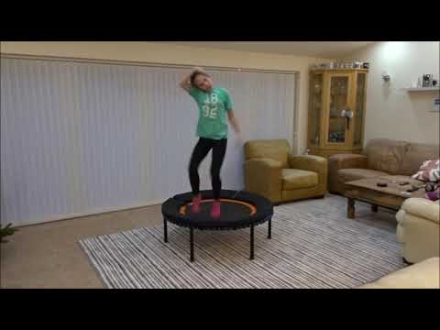](https://www.youtube.com/watch?v=niAimfQc8NE)**If the link in the video thumbnail above does not play the video on your device, please use this web page to view:   
<https://www.youtube.com/watch?v=niAimfQc8NE>

Grade 1, Exercise 10.1: Sitting position - bounce and crossover shoulder touch (right hand to left shoulder, left hand to right shoulder), hip crossover, knee crossover

Grade 2, Exercise 19: Run on centre of bed - crossover knee slapping (right hand to left knee, left hand to right knee)

Grade 2, Exercise 20: Run on centre of bed - low crossover (right hand to left leg, left hand to right leg, reaching below the knee keeping leg straight)

Grade 2, Exercise.20-1: Run on centre of bed - crossover to shoulders, ears over the head,.

Grade 2, Exercise 5.1: Sitting position - bounce and air guitar - left handed and right handed

Grade 2, Exercise 5.2: As G2, Ex 5.1 but alternating right and left handed with every bounce